

System Admin

Training Assignments

|  |  |
| --- | --- |
| Program Code |  |
| Issue/Revision | x/y |
| Effective date | 04/Aug /2023 |

Assignment Day 09. System Software - Day 4

Mục Lục:

Hướng dẫn cài đặt Active Directory 2

Install Active Directory Domain Services On Windows Server 2022 3

Setup Active Directory Domain 2022 4

Verify Active Directory Installation 4

# Hướng dẫn cài đặt Active Directory

# Install Active Directory Domain Services On Windows Server 2022

To install Active Directory, Server 2022 must be installed and fully updated.

After the updates are installed, open the Server Manager application.  
Once open, select the Ethernet connection so a static IP address relevant to the environment can be set.

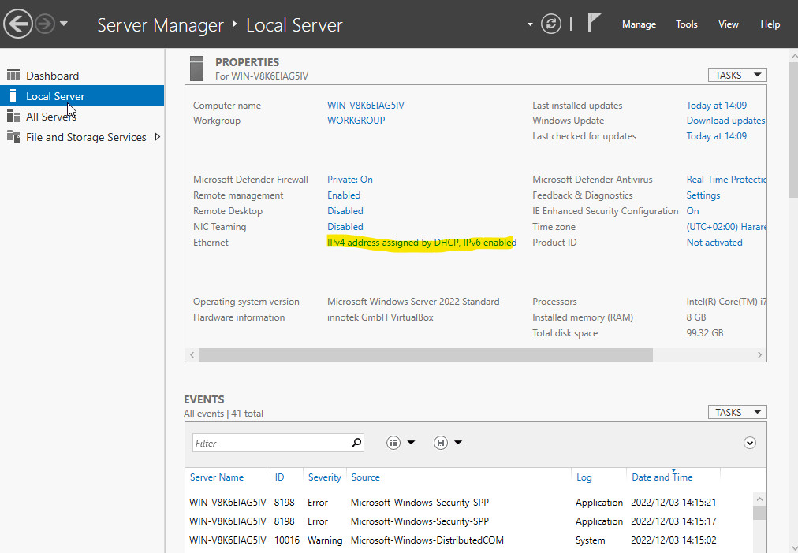  
Select the Ethernet adapter and open the Properties.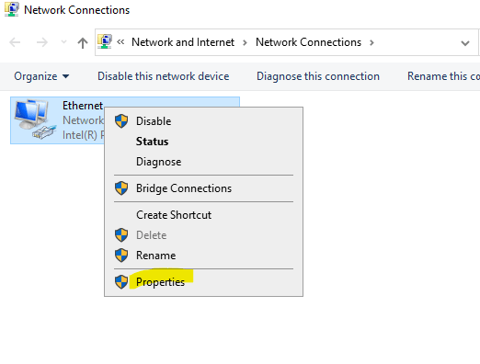  
Under properties, select the TCP/IPv4 and click Properties.  
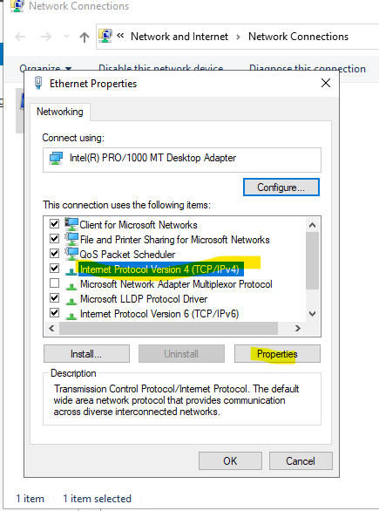  
Select the radio button to Use the following IP address.  
Specify a free IP address in the network, as well as the subnet mask and correct default gateway, and click OK  
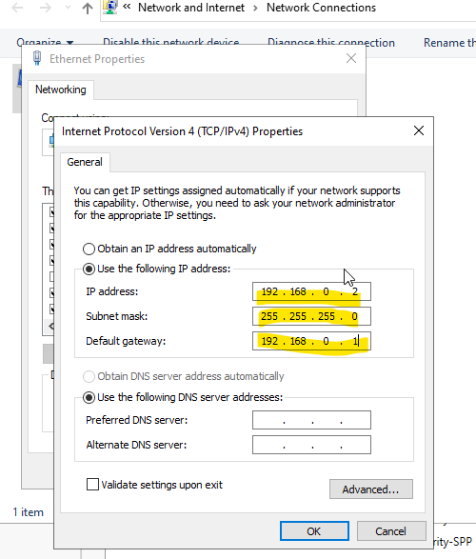

Next, select the computer name under the Server Manager to change it.  
The server will need a valid name before installing Active Directory.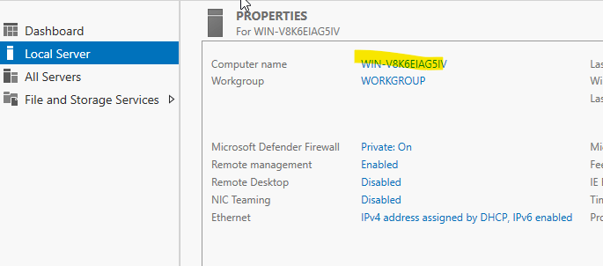

On the System Properties window that opens, select Change.  
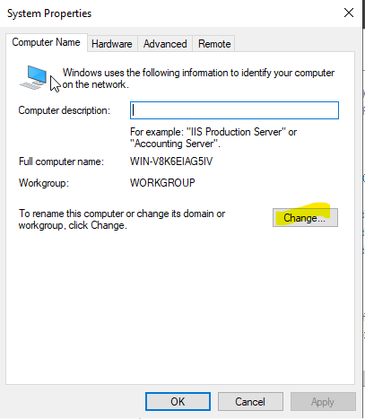  
Create a meaningful name for the server in our example DC1 and click OK.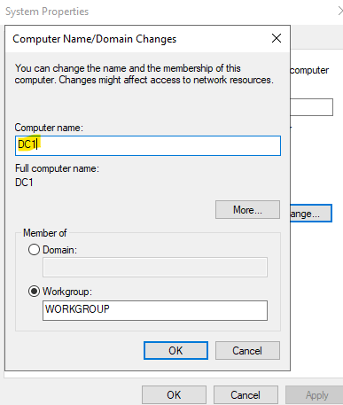

Click Ok to acknowledge that the computer needs to be restarted.

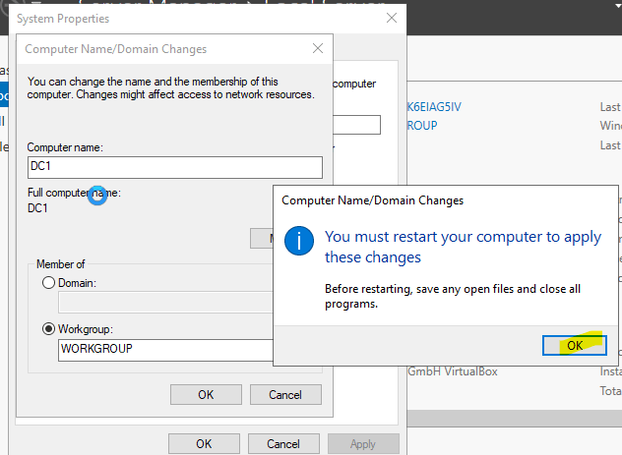

Click Restart Now  
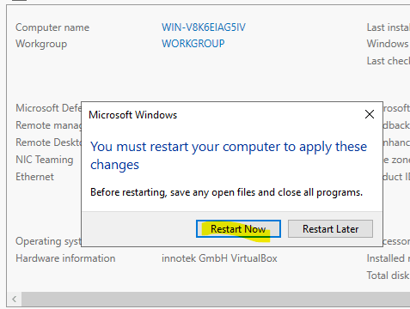

After restart, the new IP address and computer name are visible when checking the Server Manager.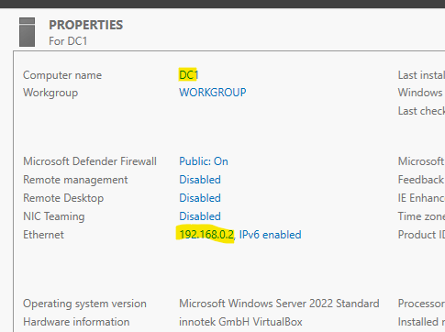

In the Server Manager, select Manage, and then Add Roles and Features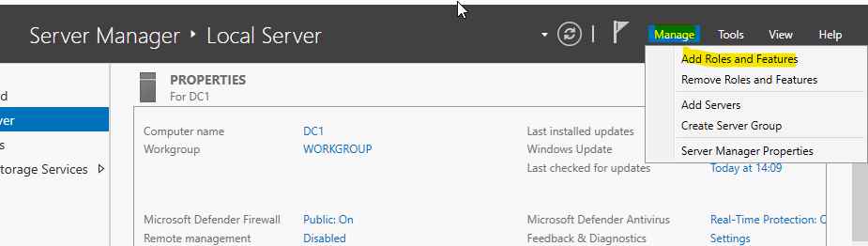

The wizard will give basic information; click Next.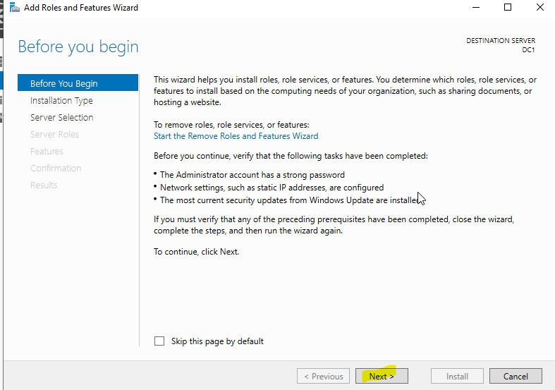

Select Role-based or feature-based installation and click Next.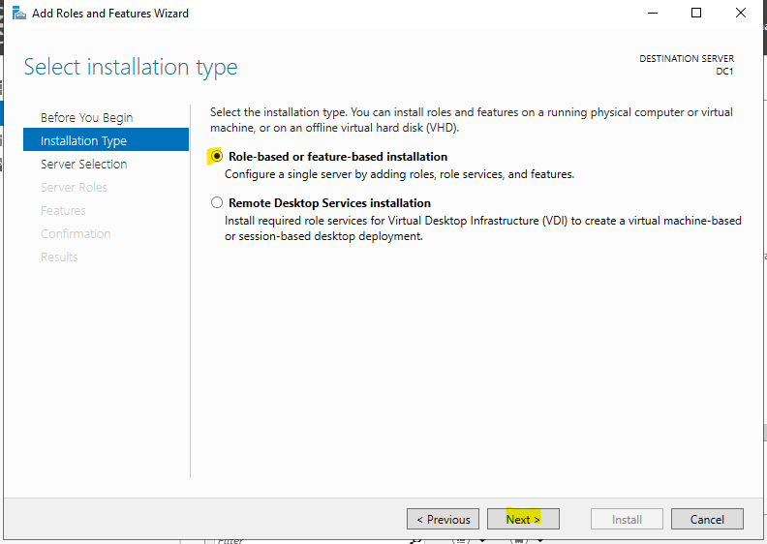

Should there be multiple servers in the environment, ensure the correct server is selected and click Next.  
Should there only be one server, the above can be ignored. Just click Next.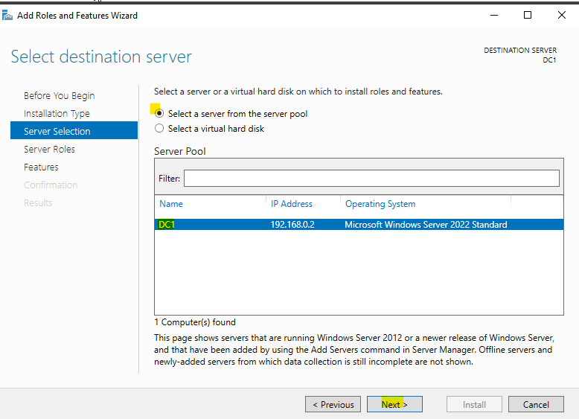

On the server roles list, select Active Directory Domain Services.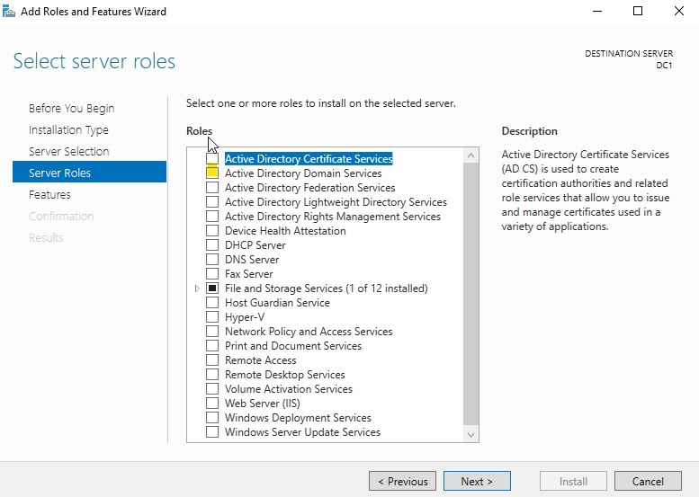

Leave the tick box ticked to Include management tools, and click Add Features.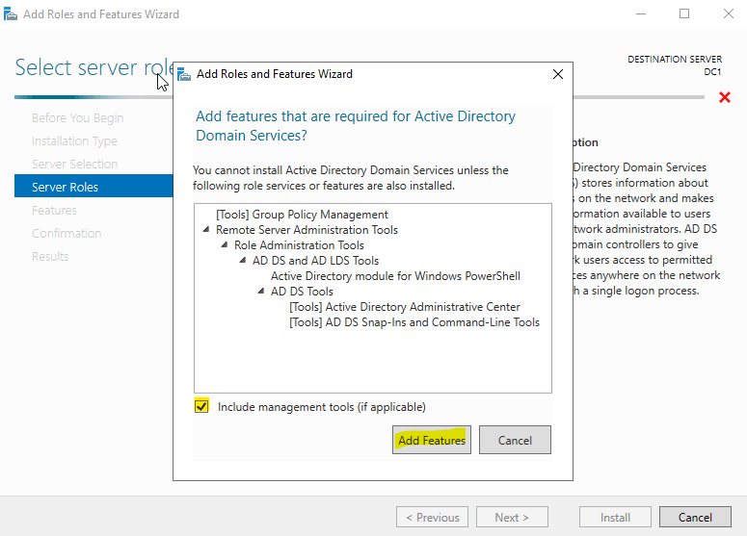

Active Directory Domain Services will now be ticked. Click Next.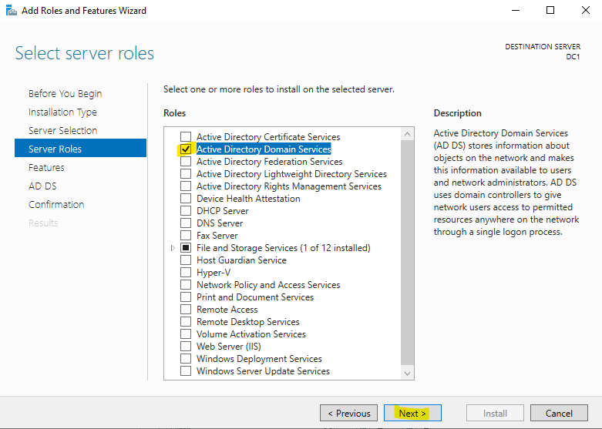

For the Features, click Next with no changes.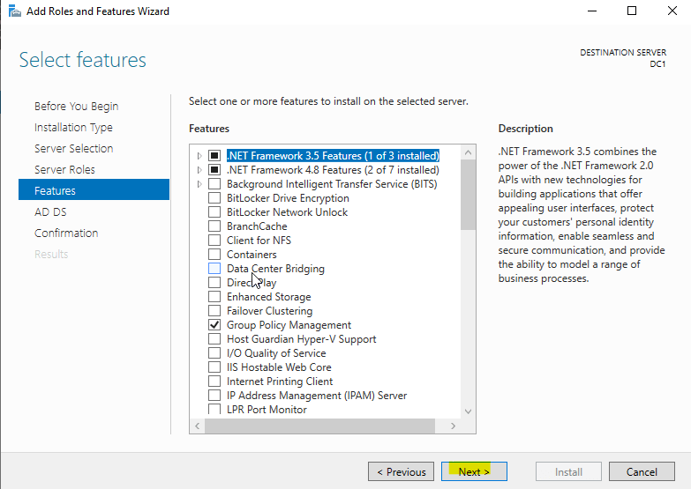

The Active Directory Domain Services will make some suggestions that are very important for production environments, namely:  
Install a minimum of two domain controllers so users can log in even if there is a server outage.  
A Microsoft DNS server must be set up in the network.  
Click Next.

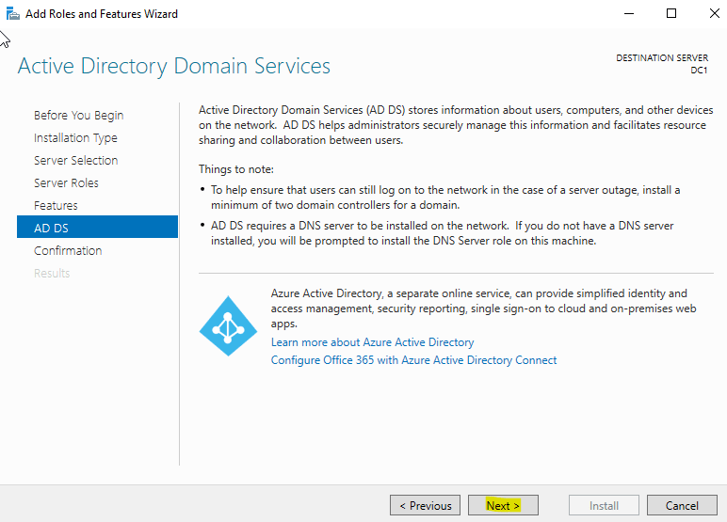

Ticking the option to restart automatically for test environments will speed up the installation process. This should be used with caution for production environments.  
Click Install.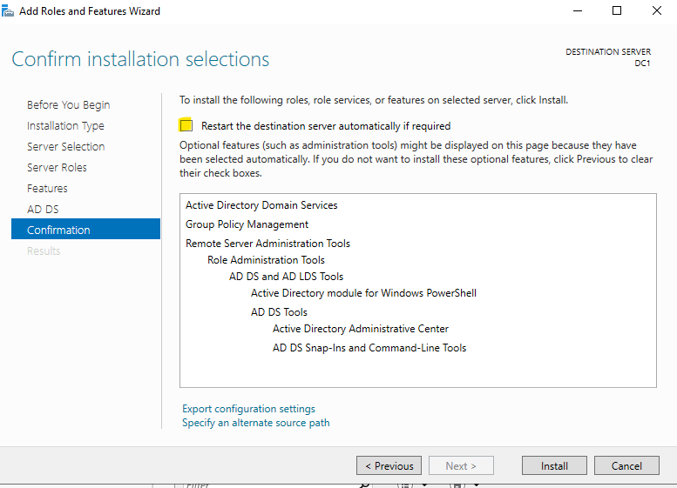  
If the option to restart was selected, click Yes to allow the automatic restart.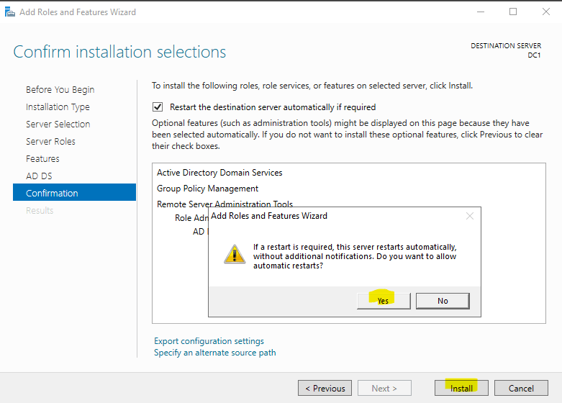

Installation of the Active Directory Domain Services will now run.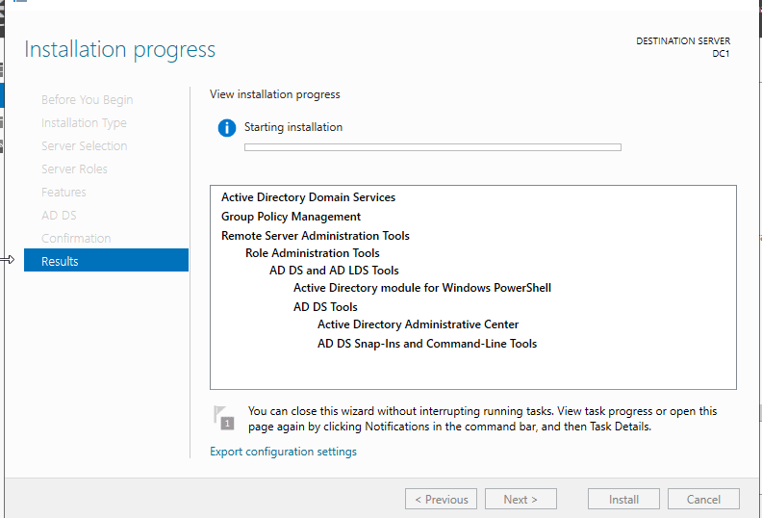

Once completed, select the option to Promote this server to a domain controller.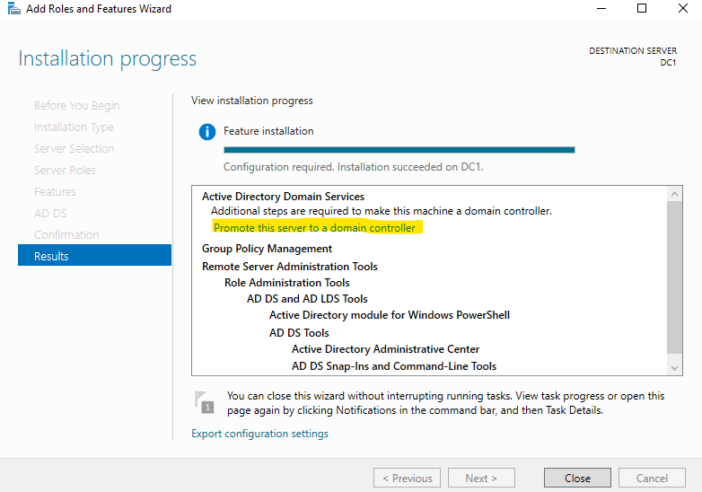

# Setup Active Directory Domain 2022

At this point, the Active Directory Domain service has been installed on your server. Now, you will need to set up it on the server.

Follow the below steps to set up the Active Directory Domain:

After the Active Directory Domain service installation, you should see the yellow notification icon on the Server Manager:

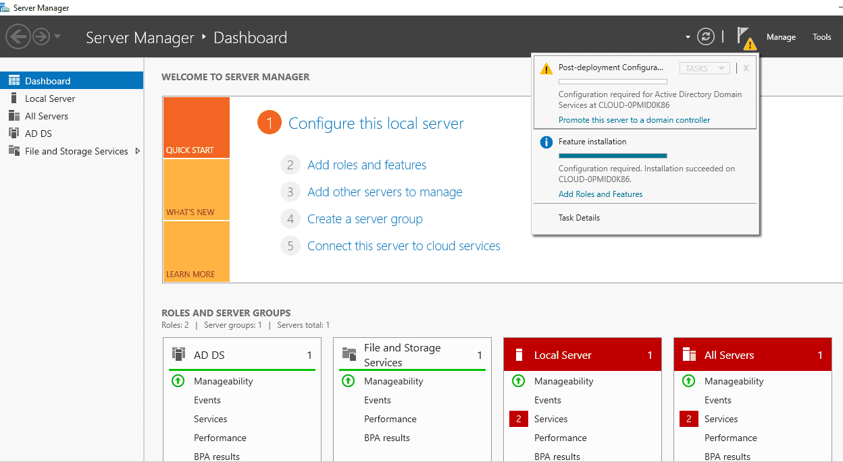

As this is a new domain, we will create a new forest.  
For the root domain name, it is best to use a subdomain of an existing public FQDN (Fully Qualified Domain Name).  
For example, adtest.foldersecurityviewer.com.  
Should you not have a public domain, replacing the .com on the end with .local will work for test domains.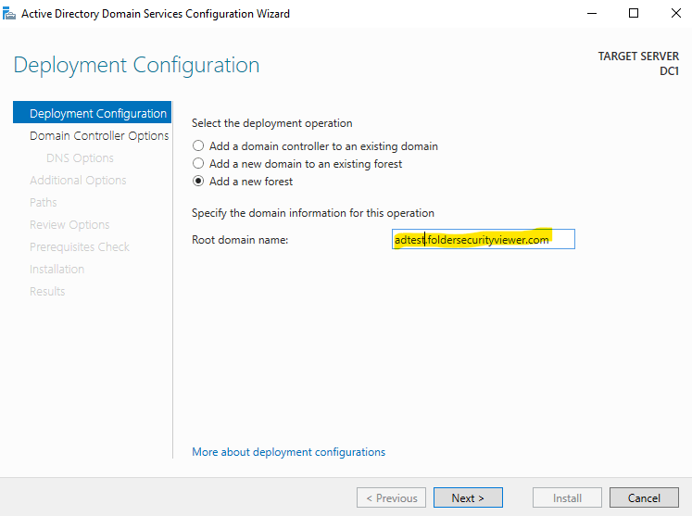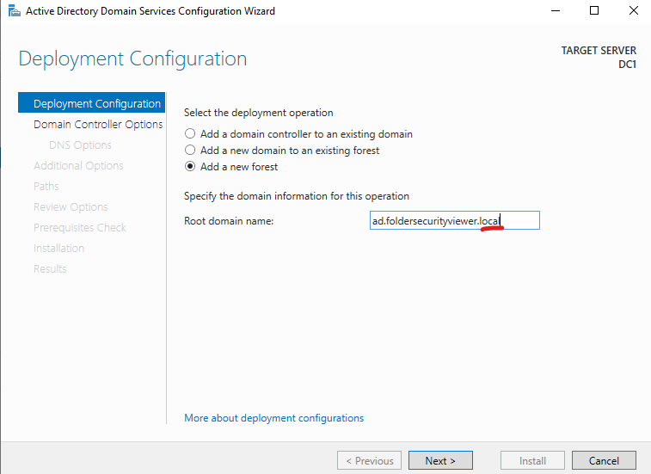

When setting up the domain controller for the first time, certain decisions will need to be made.  
Forest Functional Level is the minimum Operating System version for all servers in all sub-domains.  
Domain Functional Level could be set higher than the Forest level, but not lower.  
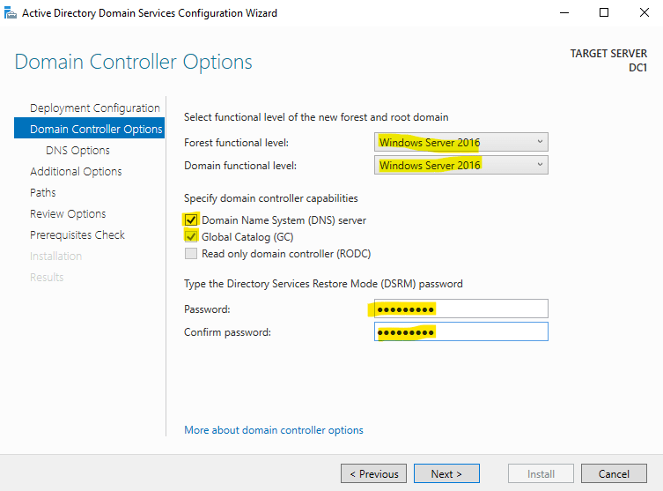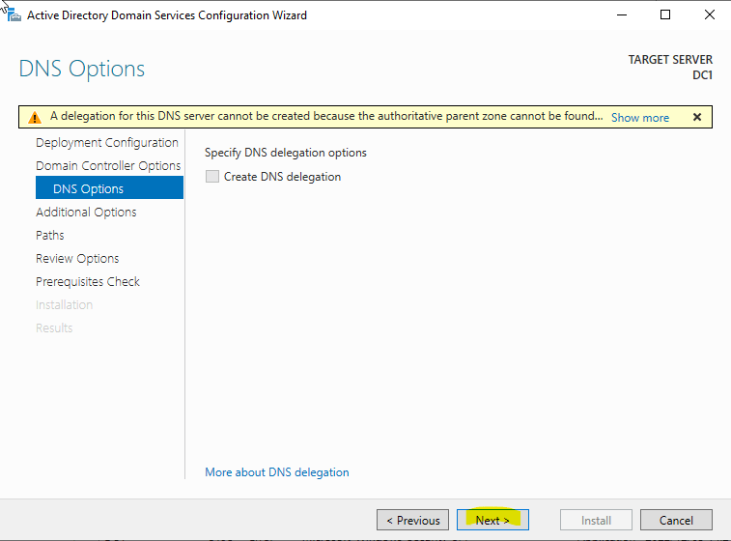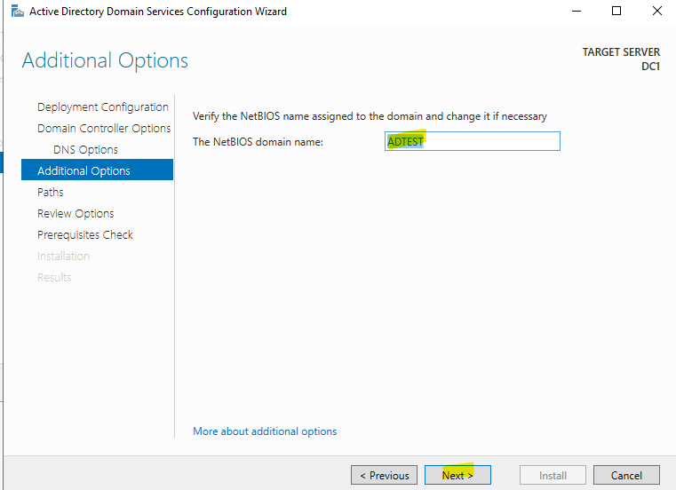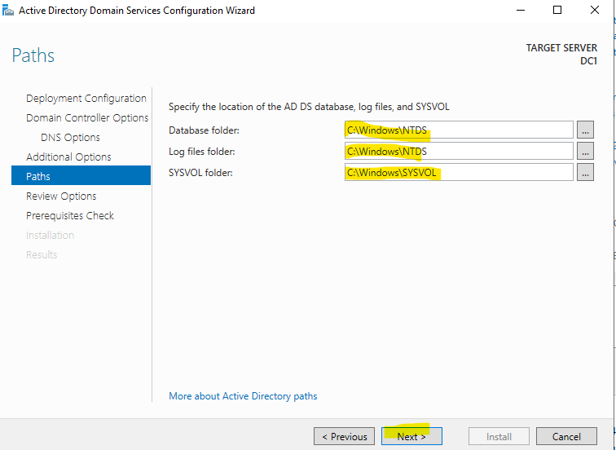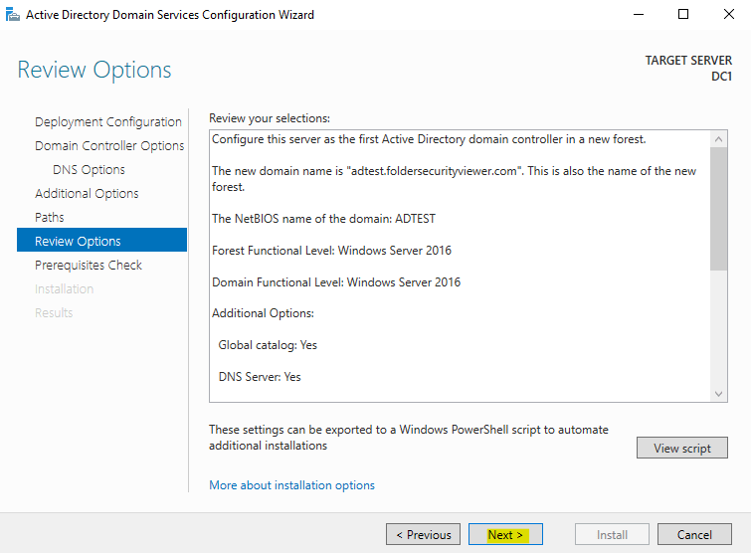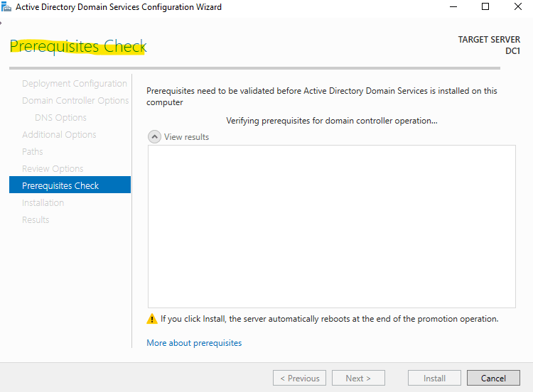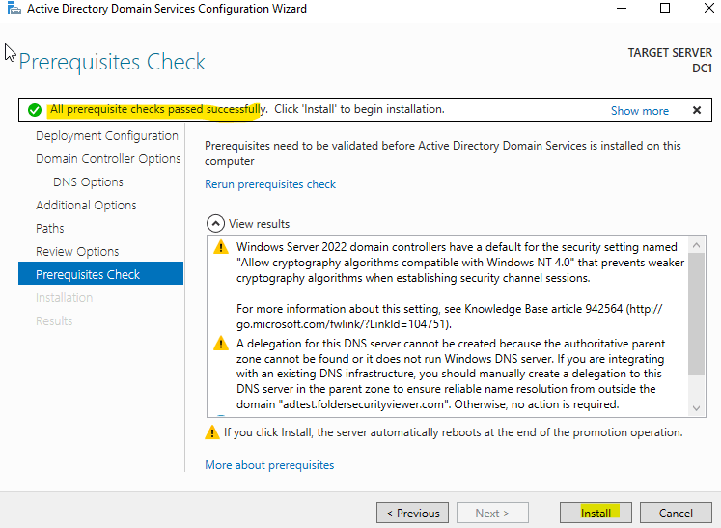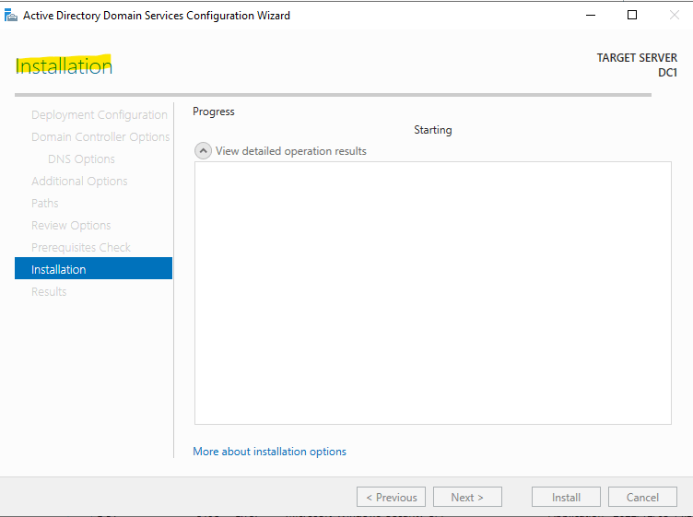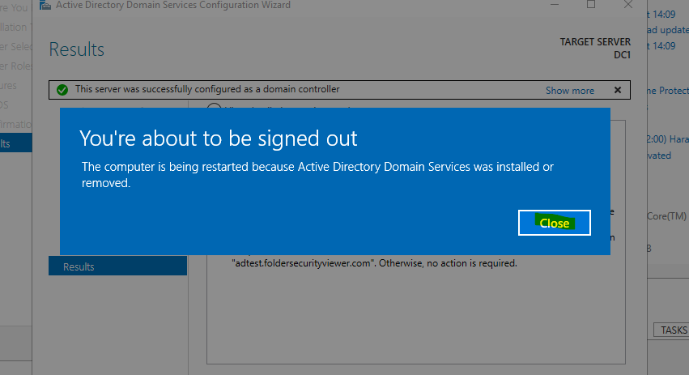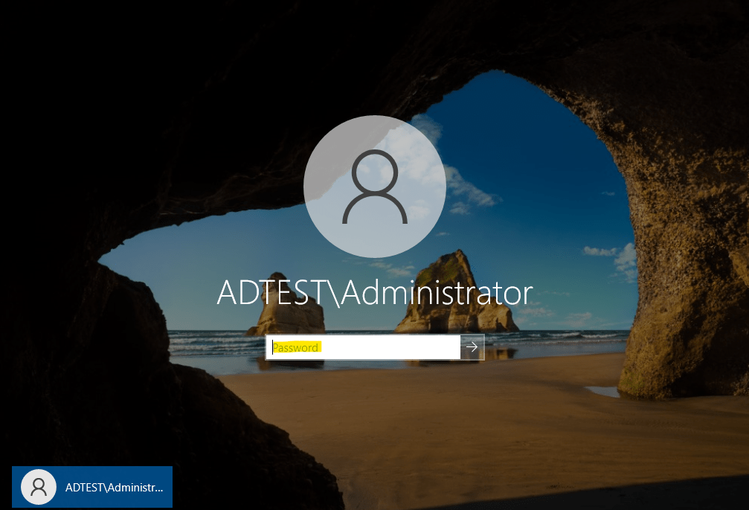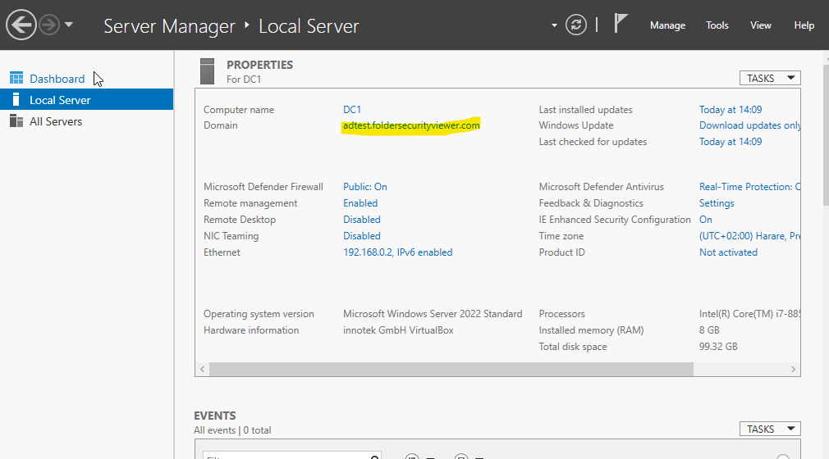

# Verify Active Directory Installation

After installing and setting up Active Directory Domain, you will need to verify whether the Domain Controller is set up or not.

To verify, open the Windows PowerShell and run the following command:

**Get-Service adws,kdc,netlogon,dns**

Copy

You should see the status of all services in the following output:

Status Name DisplayName  
------ ---- -----------  
Running adws Active Directory Web Services  
Running dns DNS Server  
Running kdc Kerberos Key Distribution Center  
Running Netlogon netlogon

Copy

To display the information of your domain controller, run the following command:

**Get-ADDomainController**

If you want to see detailed information of your domain, run the following command:

**Get-ADDomain exampledomain.com**